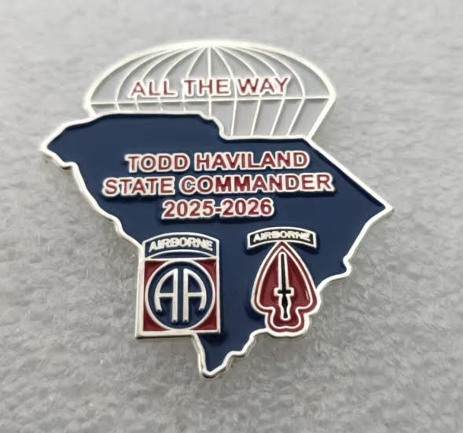

**2025- 2026**

**COMMUNITY SERVICE REPORT FORM** **FOR INDIVIDUAL COMRADES**

**(Including Post Auxiliaries) Complete all highlighted items please!**

**Post/Auxiliary Number: ________ District Number ________**

***This form is for individual comrades to provide their contributions for Community Service to their Post Commander. The Commander’s designated reporting official will consolidate these reports at least monthly and submit monthly Community Service Activity reports electronically using the report form at: our Department website*** [**https://vfwsc.org**](https://vfwsc.org)

**DATE OF ACTIVITY___________**

**SELECT A PROGRAM (Circle your choice)**  (See definitions of each category below):

Community service Americanism/ Citizen Education Youth Activities Safety Veterans and Military Support(VMS) Voice of Democracy Patriots Pen Teacher of Year/ Scouting Program

**TOTAL HOURS___ TOTAL MILES____ TOTAL MEMBERS_____ $DONATED______**

(example: **12 Total Hours,** 24 miles, 4 Members (each performed 3 hours service)

**Description of your project** or activity and **how it meets the criteria** for your chosen program in the categories listed below

________________________________________________________________________________________________________________________________________________________________________________________________________________________________________________________________________________________________________________________________________________________________________________________________________________________________________________________________________________________________________

(use reverse side of this form for more space**)**

**Categories of Community Service:**

**COMMUNITY SERVICE** includes any activities within your community which help to benefit the community, church, school, parks, recycling, neighborhood cleanings, adopt a road program etc.

**AMERICANISM/CITIZEN EDUCATION** - teach someone about flag etiquette, military service, etc.

**YOUTH PROGRAMS** include the annual Voice of Democracy, Patriot's Pen, Scout of the Year Program, etc.

**YOUTH ACTIVITIES** - Posts and Auxiliaries are encouraged to provide youth programs within the community such as Athletics, Scouting, School Assemblies, Veterans in the classroom, Contests, Recognition, etc.

**SAFETY** - Pedestrian, Drug Awareness, Highway, Home/Fire, etc **Only the Comrade giving the brief gets credit on the report.**

**VMS** - Any support given to a unit, an individual family member, ceremonies, welcome home, T2T., Unmet Needs, USO, etc